“Course Recommendation System”

A Project Report Submitted in the partial fulfillment of the requirements for the award of the degree of

BACHELOR OF TECHNOLOGY

in

DEPARTMENT OF COMPUTER SCIENCE ENGINEERING

by

Mahitha :2520030469

Vineetha :2520030149

Under the Guidance of

Vinay Kumar
Associate Professor
Department of Computer Science and Engineering





2026-27

DEPARTMENT OF COMPUTER SCIENCE ENGINEERING

Declaration

The Project Report entitled “Course Recommendation System” is a record of bonafide work of Mahitha – 2520030469 and Vineetha – 2520030149 submitted in partial fulfillment for the award of B. Tech in Computer Science and Engineering. The results embodied in this report are based on the implementation and testing of the proposed Course Recommendation System.

Mahitha – 2520030469
Vineetha – 2520030149

DEPARTMENT OF COMPUTER SCIENCE ENGINEERING

CERTIFICATE

This is to certify that the mini project based report entitled “Course Recommendation System” is a bonafide work done and submitted by Mahitha – 2520030469 and Vineetha – 2520030149 in partial fulfillment of the requirements for the award of the degree of BACHELOR OF TECHNOLOGY in Department of Computer Science Engineering, during the academic year 2026-27.

Signature of the Guide Signature of the HOD
(Vinay Kumar)
ACKNOWLEDGEMENT

We express our sincere gratitude to our guide, Vinay Kumar, Associate Professor, Department of Computer Science and Engineering, for his guidance, suggestions and continuous support throughout the development of the Course Recommendation System. His feedback helped us organize the project into clear modules and improve the implementation.

Mahitha – 2520030469
Vineetha – 2520030149

Abstract

Choosing a suitable course or specialization can be difficult when a student has many possible options and does not know which areas best match their interests and skills. The Course Recommendation System is a terminal-based Java application designed to provide relevant course recommendations from a collection of 100 corpus text files. Each corpus file contains structured information about a course or specialization, including its description, interests, preferred school subjects, skills needed, prerequisites, career options, future scope and reasons for recommendation.

The system combines KMP, Z-algorithm and Edit Distance to compare a user's entered interest with the information stored in the corpus. KMP and the Z-algorithm are used for string matching, while Edit Distance helps identify closely related terms when an exact match is not found. The matching results are ranked so that the most relevant courses can be presented to the user. The application is organized into modules such as corpus loading, course representation, recommendation, KMP matching and Edit Distance calculation. The planned extensions for CO4-CO6 are maximum-flow/bipartite matching for interest-to-course assignment, a 2-approximation Vertex Cover algorithm on a course-skill relationship graph, and randomized hashing for keyword candidate lookup. These extensions must be implemented and tested before they are described as completed features.

The final terminal output provides the recommended course information in a readable form. Along with the recommendation, the system can display the course description, prerequisites, skills required, career opportunities, future scope and other relevant details. The project demonstrates how fundamental data structures and string algorithms can be combined to build a practical recommendation system without requiring a graphical user interface.
Table of Contents

 |  |  | Page No.
 | Acknowledgement
 | Abstract
 | Table of Contents
 | List of Figures
1 | Introduction | 1.1 Overview  1.2 Problem Statement  1.3 Objectives  1.4 Scope of the Project  1.5 System Workflow | 1
2 | System Requirements | 2.1 Functional Requirements  2.2 Non-Functional Requirements  2.3 Hardware Requirements  2.4 Software Requirements  2.5 Corpus Requirements | 3
3 | System Design | 3.1 System Architecture  3.2 System Modules  3.3 Corpus Structure  3.4 KMP Matching Module  3.5 Edit Distance Module  3.6 Recommendation Ranking  3.7 System Flow | 5
4 | Implementation | 4.1 Module-wise Implementation  4.2 Corpus Loading  4.3 Keyword Matching  4.4 Edit Distance Matching  4.5 Recommendation Generation  4.6 Pseudocode  4.7 Terminal Output | 7
5 | Results | 5.1 Test Cases  5.2 Sample Results  5.3 Recommendation Details  5.4 Result Analysis  5.5 Screenshot Placement Guide | 9
6 | Challenges & Limitations | 6.1 Issues Faced During Development  6.2 Solutions Applied  6.3 Limitations of the System | 11
7 | Conclusion & Future Work | 7.1 Conclusion  7.2 Future Work  7.3 Skills Learned During Development | 12
 | References | - Books, tutorials, APIs, documentation sites used | 13

List of Figures

3.1 System Architecture of the Course Recommendation System
3.2 Flow Chart of the Recommendation Process
4.1 Corpus Folder and Course Files
5.1 Terminal Input for Course Interest
5.2 Terminal Recommendation Output
5.3 Detailed Course Recommendation Information
5.4 Additional Test Case Output
Page numbers for figures should be updated after the screenshots are inserted.

1. INTRODUCTION
1.1 Overview
The Course Recommendation System is a terminal-based Java application that helps students explore suitable courses or specializations based on an interest entered by the user. Instead of depending on a single fixed course list, the system searches a corpus containing 100 text files. Each file represents a course or specialization and stores useful information that can help a student understand the option before making a decision.
The project focuses on combining simple but effective string-processing techniques with a structured corpus. The recommendation process uses KMP and Z-algorithm string matching to identify exact matches and Edit Distance to handle closely related or misspelled terms. The result is then ranked and presented through the terminal.
The recommended information is not limited to a course name. The output can include the course description, interests, preferred school subjects, skills needed, prerequisites, entrance examinations, duration, career options, future scope and why the course is recommended.

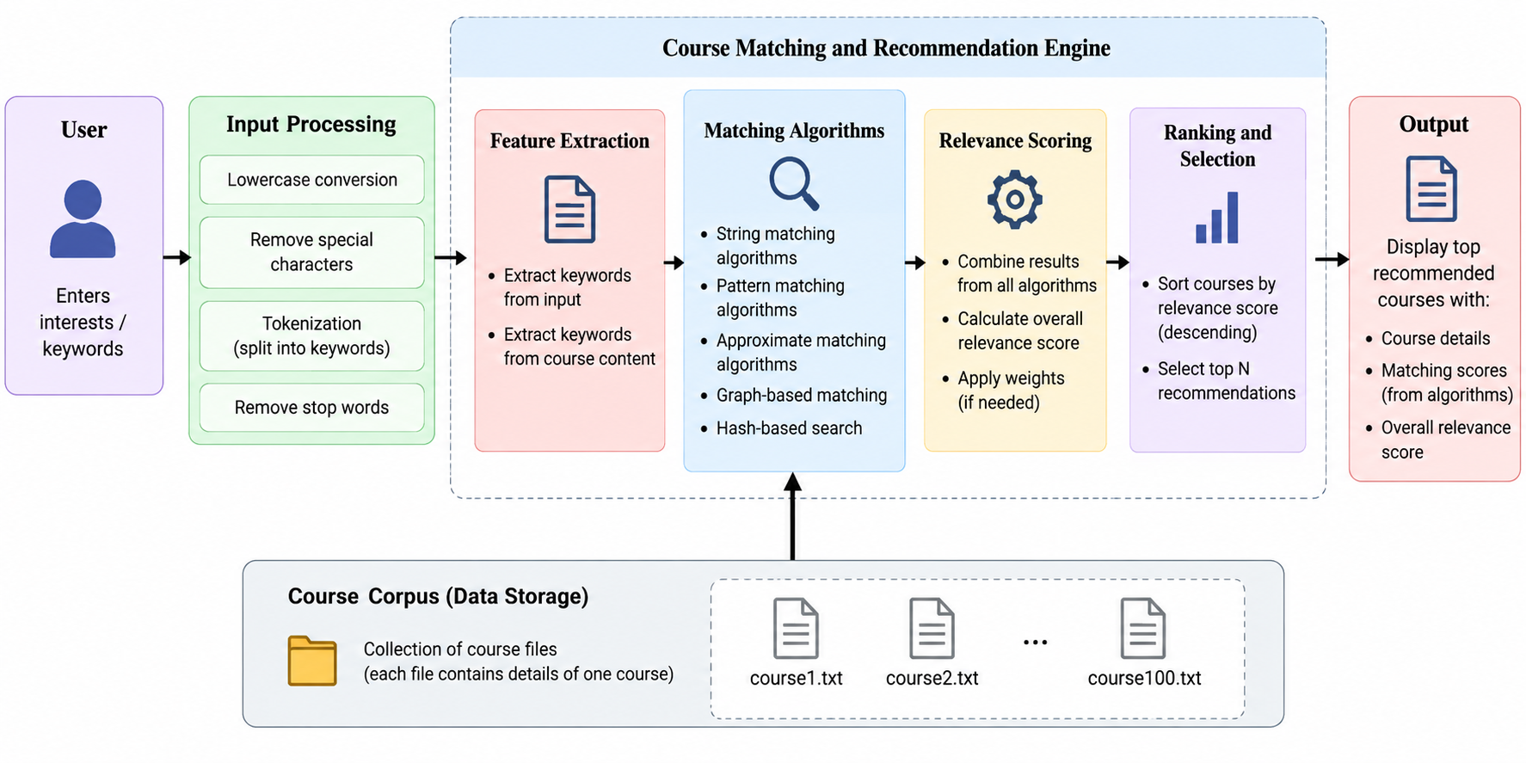
Fig. 1.1 System Architecture of the Course Recommendation System
1.2 Problem Statement
Students often have difficulty selecting a course because many specializations have similar names or overlapping career paths. Searching manually through large amounts of course information is time-consuming, and a student may not know which keywords to use. The problem addressed by this project is to build a simple recommendation system that accepts an interest as input, searches a prepared course corpus, and returns relevant course information in a clear terminal-based format.
1.3 Objectives
• To develop a terminal-based course recommendation system using Java.
• To maintain a corpus of 100 text files containing course and specialization information.
• To use KMP and Z-algorithm string matching for exact keyword matching within the corpus.
• To use Edit Distance to identify closely related terms when exact matching is insufficient.
• To rank matching courses and present useful recommendation details to the user.
• To use maximum flow / bipartite matching to model interest-to-course-category assignment (CO4).
• To apply the 2-approximation Vertex Cover algorithm to a graph of related course skills (CO5).
• To use randomized hashing for candidate keyword lookup and compare it with scanning the corpus (CO6).
• To provide information such as description, prerequisites, career opportunities and future scope.
1.4 Scope of the Project
The system is designed as a lightweight academic recommendation application. Its main scope is course and specialization discovery using a locally stored corpus. The corpus can cover areas such as Technology, Healthcare, Business, Design, and Arts and Social Sciences. The system is intended to demonstrate how string algorithms and structured text data can be combined for a practical recommendation task.
The current implementation is terminal based and does not require an online service or a graphical interface. This keeps the project focused on the recommendation logic, corpus processing, string matching and ranking mechanisms.
1.5 System Workflow
The user enters an area of interest through the terminal. The system loads the available corpus files, reads the course information, and checks the user's keyword against relevant text. KMP is applied for exact matching. If an exact match is not sufficient, Edit Distance is used to measure how closely the entered term matches stored course or interest terms. The matching courses are then ranked and their detailed information is displayed.
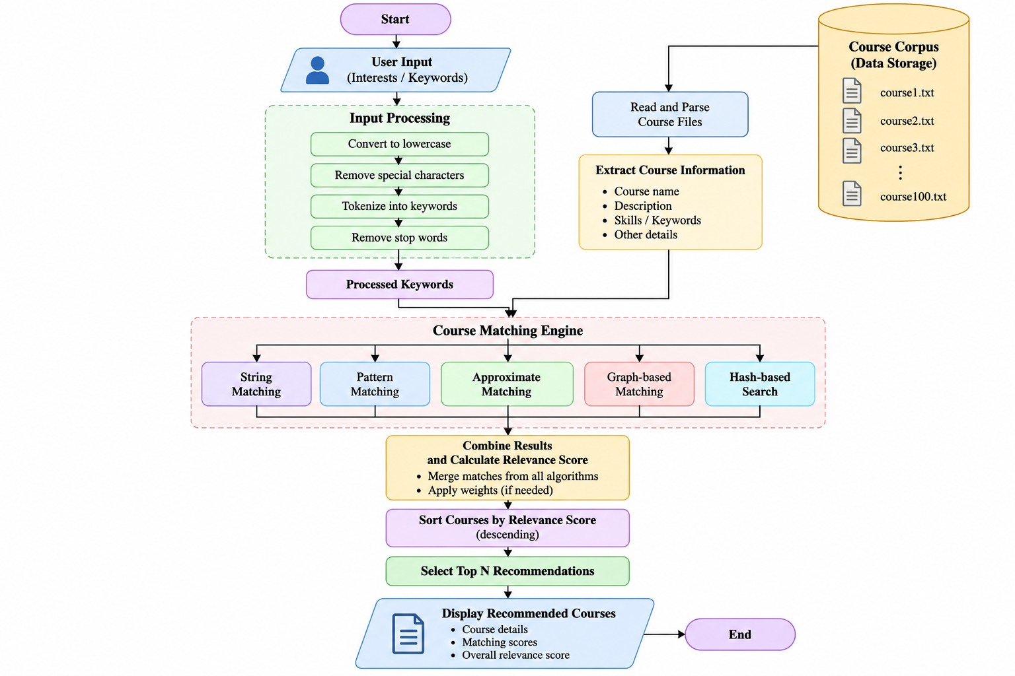
Fig. 1.2 Flow Chart of the Recommendation Process
2. SYSTEM REQUIREMENTS
2.1 Functional Requirements
• The system shall accept a course interest or keyword from the user through the terminal.
• The system shall load course information from the 100 corpus text files.
• The system shall search the corpus for relevant keywords and course interests.
• The system shall perform exact matching using KMP.
• The system shall calculate similarity using Edit Distance when required.
• The system shall rank the matching courses.
• The system shall display recommendation details and supporting course information.
2.2 Non-Functional Requirements
• Usability: the terminal interaction should be simple and understandable.
• Performance: corpus searching should be efficient enough for the 100-file dataset.
• Reliability: invalid or unmatched input should not terminate the program unexpectedly.
• Maintainability: corpus data and algorithm modules should remain separate from the main program flow.
• Portability: the Java application should be runnable on systems with a compatible JDK.
2.3 Hardware Requirements
A standard computer or laptop with sufficient storage for the Java project and the 100 corpus files is adequate. No specialized hardware is required because the project is a software-based terminal application.
2.4 Software Requirements
• Java Development Kit (JDK).
• Java source files for the main application and recommendation modules.
• A Java-compatible IDE or text editor.
• Operating system capable of running Java and accessing the corpus directory.
• A folder containing the 100 course corpus text files.
2.5 Corpus Requirements
The corpus contains 100 text files. The files store course or specialization records using fields such as Specialization, Category, Description, Interests, Preferred School Subjects, Skills Needed, Prerequisites, Entrance Exams, Duration, Career Options, Future Scope and Why Recommended. Keeping the information in separate text files makes the dataset easy to extend without changing the main recommendation logic.
3. SYSTEM DESIGN
3.1 System Architecture
The system is organized into a small set of Java modules. The Main module handles user interaction and invokes the recommendation process. The corpus loader reads the course files and converts their contents into course records. The Course Recommender coordinates matching and ranking. The KMP module performs exact string searching, while the Edit Distance module calculates the difference between two terms.
The overall architecture can be viewed as five stages: user input, corpus loading, string matching, recommendation ranking, and terminal output. The separation of these stages keeps the algorithms independent from the user interface and makes the system easier to modify.
[ INSERT SCREENSHOT HERE ]
Fig. 3.1 System Architecture of the Course Recommendation System
3.2 System Modules
Main.java: Starts the application, accepts the user's interest, loads the corpus and calls the recommendation process.
CorpusLoader.java: Reads the corpus text files and prepares the course information for processing.
Course.java: Represents the information associated with a course or specialization.
CourseRecommender.java: Coordinates matching, scoring, ranking and generation of recommendation results.
KMP.java: Implements the Knuth-Morris-Pratt string matching algorithm for exact keyword matching.
EditDistance.java: Calculates the edit distance between terms so that closely related inputs can be recognized.
FlowMatcher.java: Builds an interest-to-course flow network and returns maximum-matching pairs (CO4).
SkillCover.java: Applies the 2-approximation Vertex Cover algorithm to a graph of course-skill relationships (CO5).
RandomizedCourseIndex.java: Uses randomized hashing to retrieve candidate course records before final string matching (CO6).
3.3 Corpus Structure
The corpus directory contains 100 text files. Each file corresponds to a course or specialization record. The text-based format keeps the dataset human-readable and allows new courses to be added without rewriting the recommendation algorithms.
3.4 KMP Matching Module
This project applies string-matching techniques from CO2, specifically the Knuth-Morris-Pratt (KMP) algorithm and the Z-algorithm. KMP uses the Longest Prefix Suffix (LPS) concept to avoid repeated comparisons, while the Z-algorithm uses a Z-array to identify matching prefixes. These techniques are used to match the user's interest with relevant information in the course corpus.
3.5 Edit Distance Module
Edit Distance measures how many single-character insertions, deletions or substitutions are needed to transform one string into another. The project uses this technique to compare the entered interest with stored course or interest terms. A smaller distance indicates a closer match and can therefore contribute to a stronger recommendation.
3.6 Recommendation Ranking
After the corpus is searched, the recommendation module combines the matching information to rank candidate courses. Exact keyword matches provide strong evidence of relevance, while smaller edit distances provide useful matches for closely related terms. The ranked results are then converted into readable course recommendations.
3.7 System Flow
• Start the Java application.
• Read the user's interest from the terminal.
• Load the course records from the corpus.
• Search for exact matches using KMP.
• Use Edit Distance to identify closely related terms when needed.
• Calculate the relevance of candidate courses.
• Rank the candidate courses.
• Display the course recommendation and its detailed information.
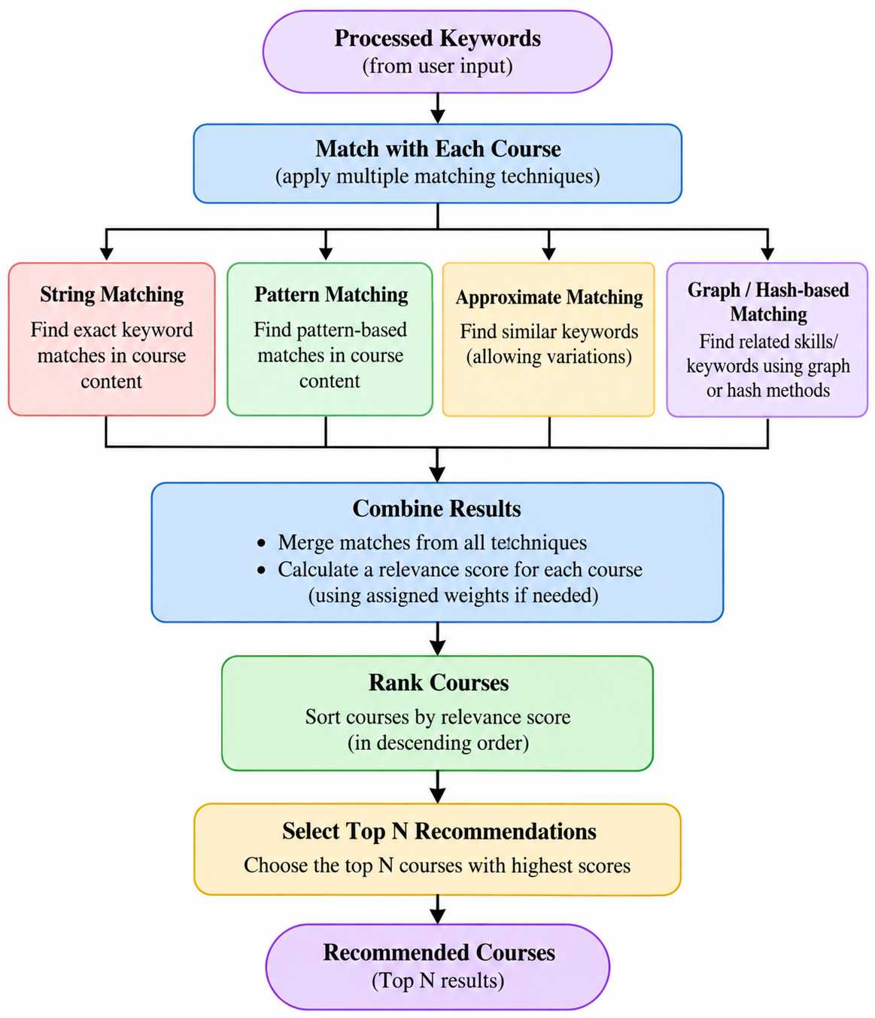
Fig. 3.3 Flow Chart of the Recommendation Process
4. IMPLEMENTATION
3.8 Additional Algorithms for CO4, CO5 and CO6
CO4: Maximum Flow and Bipartite Matching
Represent user-interest categories and course categories as the two sides of a bipartite graph. Connect an interest to a course category when the corpus indicates a relationship. Add a source and sink with capacity-one edges, then use an augmenting-path maximum-flow method based on Edmonds-Karp to find a maximum matching. Return the matched pairs as an additional recommendation signal. Test the module on a small graph with a known answer.
CO5: 2-Approximation Vertex Cover
Build a graph where each vertex is a skill and each edge represents a documented overlap or relationship between two skills in course records. Repeatedly select an uncovered edge, add both endpoints to the cover, and remove all edges incident to either endpoint. This gives a vertex cover whose size is at most twice the optimal cover size. Display the selected skills and verify that every graph edge is covered.
CO6: Randomized Hashing for Candidate Lookup
Create an index from normalized course keywords to hash buckets using a documented randomized hash function or seed. Retrieve candidate records through the index, then verify them with the existing KMP, Z-algorithm and Edit Distance logic. Handle collisions by comparing the stored keyword. Compare lookup with a full corpus scan using the same test queries, reporting measured records inspected or elapsed time.
4.1 Module-wise Implementation
The implementation follows a modular Java structure. Main.java contains the application flow and calls the required classes instead of placing all logic in one file. The corpus loader handles file reading, while the recommendation class coordinates the algorithms and produces the final result.
4.2 Corpus Loading
The corpus loader accesses the course text files from the Corpus directory and reads their contents. Each file is converted into a course record so that the recommendation module can process the information consistently. The use of separate files allows the dataset to be expanded by adding new records.
4.3 KMP and Z-algorithm Keyword Matching
The entered keyword is passed to the recommendation module. KMP and the Z-algorithm search for the keyword in the relevant course information. When the keyword is found, the course becomes a candidate for recommendation. This exact matching stage provides a direct connection between the user's interest and the corpus.
4.4 Edit Distance Matching
Edit Distance is the string-processing technique applied from CO3. It measures how many single-character insertions, deletions or substitutions are required to transform one string into another. In this project, it is used to identify closely related course or interest terms when the user's input is not an exact match.
4.5 Recommendation Generation
The Course Recommender evaluates the candidate records and ranks them according to their matching evidence. The final terminal output is designed to provide more than a course title. It can show the recommendation description, category, interests, preferred subjects, skills needed, prerequisites, entrance examinations, duration, career opportunities, future scope and the reason the course is recommended.
4.6 Pseudocode
START
Read user interest
Load all course records from the 100 corpus files
FOR each course record
Search the interest using KMP and Z-algorithm
IF an exact match is found
assign strong matching evidence
ELSE
calculate Edit Distance between the input and stored terms
use the distance as similarity evidence
END IF
END FOR
Rank candidate courses
Display the best recommendations and their course details
STOP
4.7 Terminal Output
4.7 Maximum-Flow Matching Module
The FlowMatcher module creates a source-interest-course-sink network and computes a maximum flow. Each unit of flow through an interest-to-course edge represents a selected match. Record the test graph, expected matching size and actual output after implementation.
4.8 Approximation Module
The SkillCover module constructs the skill graph and applies the 2-approximation Vertex Cover algorithm. Print the selected cover and edge list so every edge can be checked. Do not claim the result is optimal; the guarantee is that the cover is at most twice the optimal size.
4.9 Randomized Lookup Module
The RandomizedCourseIndex module indexes normalized keywords. Test present keywords, absent keywords and hash collisions. Compare its output and measured lookup effort with a scan of all corpus records.
The application is intentionally terminal based. After the user enters an interest, the system prints the recommendation results in a structured form. The output should clearly separate the recommended course information so that the user can read the description, prerequisites, career opportunities, future scope and other fields without opening the corpus files manually.
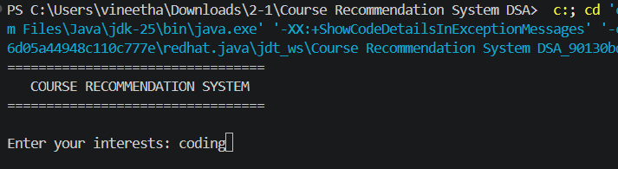
Fig. 4.1 Terminal Input for Course Interest
5. RESULTS
5.1 Test Cases
The system should be tested with different types of input to check exact matching, closely related terms and inputs that do not produce a useful match. The following test cases can be used for the final demonstration.
Test Case 1: Enter a keyword that is clearly present in one or more corpus records. Expected result: relevant course recommendations are displayed.
Test Case 2: Enter a closely related or slightly different term. Expected result: Edit Distance helps identify suitable related records.
Test Case 3: Enter a keyword with no meaningful match. Expected result: the system handles the input without crashing and indicates that a suitable recommendation could not be identified.
Test Case 4: Enter an interest associated with multiple courses. Expected result: the system ranks the matching courses and displays the most relevant results first.
5.2 Sample Results
Test Case 5: Flow matching
Use a small interest-to-course graph with a known maximum matching. Expected result: no endpoint is matched more than once and the matching size equals the expected maximum.
Test Case 6: Vertex Cover
Use a small skill-overlap graph. Expected result: every edge has at least one endpoint in the selected cover, and the cover size is at most twice the optimum for the test graph.
Test Case 7: Randomized hash lookup
Search for an existing keyword, a missing keyword and keys that collide. Expected result: correct records are returned, collisions are resolved by checking the key, and missing keywords do not produce false matches.
The final result is a set of course recommendations generated from the corpus. The terminal output should be captured directly from the working application rather than recreated manually in the report. This makes the results section evidence of the actual implementation.
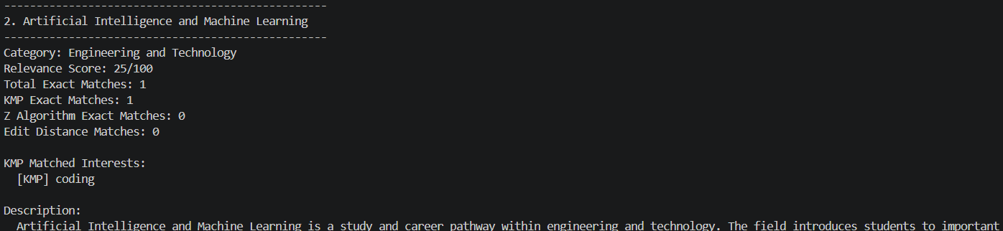
Fig. 5.1 Terminal Recommendation Output
5.3 Recommendation Details
For each recommended course, the output can include the course or specialization name, category, description, interests, preferred school subjects, skills needed, prerequisites, entrance examinations, duration, career options, future scope and why the course is recommended. These details allow the student to understand both the academic requirements and the possible career direction.
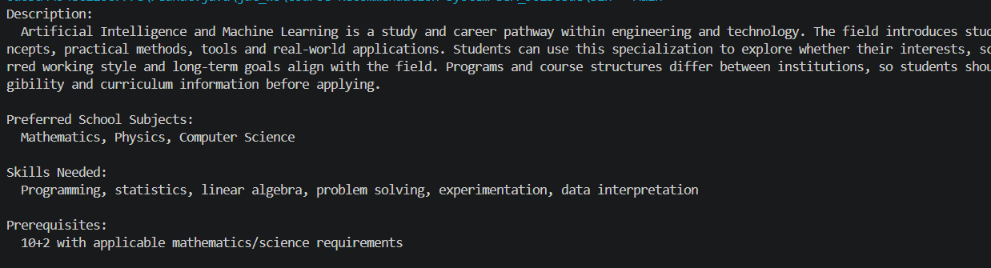
Fig. 5.2 Detailed Course Recommendation Information
5.4 Result Analysis
The results demonstrate that a relatively simple terminal application can provide useful recommendations when the corpus is organized consistently. KMP provides direct exact matching, while Edit Distance gives the system a way to recognize closely related terms. The use of a 100-file corpus also makes the system more representative than a recommendation system built from only a few hard-coded examples.
The main limitation of the result is that recommendation quality depends on the information present in the corpus and the quality of the user's input. The system does not learn from individual user history in its current form, so recommendations are based primarily on the matching relationship between the entered interest and stored course information.
6. CHALLENGES & LIMITATIONS
6.1 Issues Faced During Development
• Reading multiple corpus files consistently and keeping their information organized.
• Handling user input that does not exactly match the wording used in the corpus.
• Combining exact matching and approximate matching without making the recommendation logic unnecessarily complex.
• Presenting a large amount of recommendation information clearly in a terminal window.
6.2 Solutions Applied
The corpus was separated into individual text files so that course information could be maintained independently. The recommendation logic was divided into separate Java classes, which kept file handling, string matching and recommendation generation easier to manage. KMP and the Z-algorithm were used for string matching, while Edit Distance was used as an approximate matching method.
6.3 Limitations of the System
• The current system is terminal based and does not provide a graphical or web interface.
• The recommendations depend on the quality and completeness of the 100 corpus files.
• The current implementation does not maintain a long-term user profile or learning history.
• The system does not automatically obtain live information about universities, course fees, admissions or job markets.
• Recommendation quality can be affected when a user's interest is too broad or is not represented in the corpus.
7. CONCLUSION & FUTURE WORK
7.1 Conclusion
Implementation status note: The CO4, CO5 and CO6 extensions described above should be marked as completed only after their code runs successfully and actual result screenshots are added.
The Course Recommendation System successfully demonstrates a practical use of string algorithms for course discovery. By maintaining 100 corpus files and processing them through a modular Java application, the system can connect a user's interest with relevant course information. KMP and the Z-algorithm provide string matching, while Edit Distance supports related-term matching, after which the recommendation module ranks the candidate courses.
The terminal output provides useful information such as the course description, prerequisites, skills needed, career opportunities and future scope. The project therefore combines DSA concepts with a realistic student-oriented application while keeping the implementation simple and understandable.
7.2 Future Work
• Develop a graphical or web-based interface for easier interaction.
• Add a larger and regularly updated course corpus.
• Include user profiles and previous interests to personalize recommendations.
• Add course fees, admission information, university details and other current data.
• Use additional recommendation features such as subject preferences, skills and academic performance.
• Provide filters for duration, category, career area and prerequisite requirements.
• Add analytics to compare recommendations and explain why a particular course was selected.
• Integrate and evaluate maximum-flow / bipartite matching for interest-to-course assignment (CO4).
• Use a skill-overlap graph to demonstrate the 2-approximation Vertex Cover algorithm (CO5).
• Benchmark randomized hashing against a full corpus scan for candidate lookup (CO6).
7.3 Skills Learned During Development
• Java programming and modular class design.
• File handling and processing of text-based datasets.
• Knuth-Morris-Pratt (KMP) and Z-algorithm string matching from CO2.
• Edit Distance using dynamic programming from CO3.
• Data organization and corpus preparation.
• Recommendation scoring and ranking.
• Maximum flow and bipartite matching for assignment-style recommendations (CO4).
• Approximation algorithms and the 2-approximation guarantee for Vertex Cover (CO5).
• Randomized hashing, collision handling and performance comparison (CO6).
• Testing and debugging of a terminal-based application.
REFERENCES
T. H. Cormen, C. E. Leiserson, R. L. Rivest and C. Stein, Introduction to Algorithms, MIT Press.
D. E. Knuth, J. H. Morris and V. R. Pratt, String searching techniques and the Knuth-Morris-Pratt algorithm.
V. I. Levenshtein, Binary codes capable of correcting deletions, insertions, and reversals, Soviet Physics Doklady.
Oracle Java Documentation, Java language and standard library documentation.
Project corpus files containing course and specialization information prepared for the Course Recommendation System.

